Domain modelling
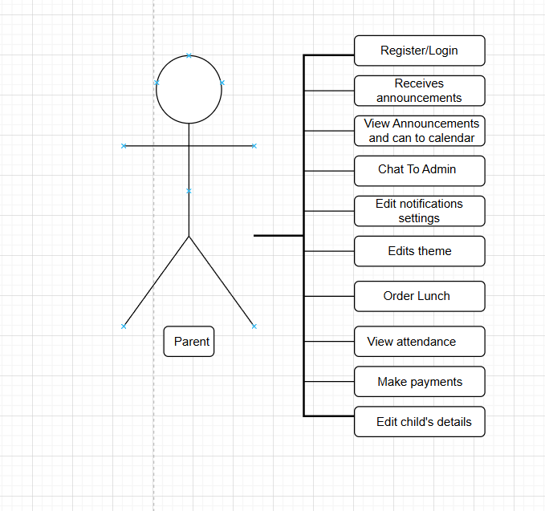

Figure 1: UML Diagram for the Parent (Mthenjana, 2025).
Actor: Parent
- The stick figure labelled Parent represents the user (the parent) who interacts with the system.
- The parent is the actor the external entity that performs actions within the app.

Use Cases
Each rounded rectangle connected to the Parent shows an action or function the Parent can perform in the system.
Here’s a breakdown:
- Register/Login
  - Parents can create an account or log in to access their dashboard and child information.
- Receives Announcements
  - Parents get notifications or updates from the crèche (e.g., events, reminders).
- View Announcements and can add to calendar
  - Parents can view announcements and optionally add important ones to their personal calendar.
- Chat To Admin
  - Provides a messaging feature for communication between parents and administrators or teachers.
- Edit Notification Settings
  - Parents can manage how they receive alerts — e.g., via email, push notifications, or SMS.
- Edits Theme
  - Allows parents to customize the app’s appearance (e.g., light/dark mode, colour scheme).
- Order Lunch
  - Parents can order or prepay meals for their children through the app.
- View Attendance
  - Parents can monitor their child’s daily attendance records and check-ins/check-outs.
- Make Payments
  - Parents can pay fees, lunch orders, or other charges directly through integrated payment options.
- Edit Child’s Details
  - Parents can update or correct their child’s personal information (e.g., allergies, contact info).

Purpose of the Diagram
- This use case diagram visually explains what the Parent can do in the app.
- It focuses on user interaction, not how the system works internally.
- It helps during design and documentation to define user requirements clearly.
(OpenAI, 2025)

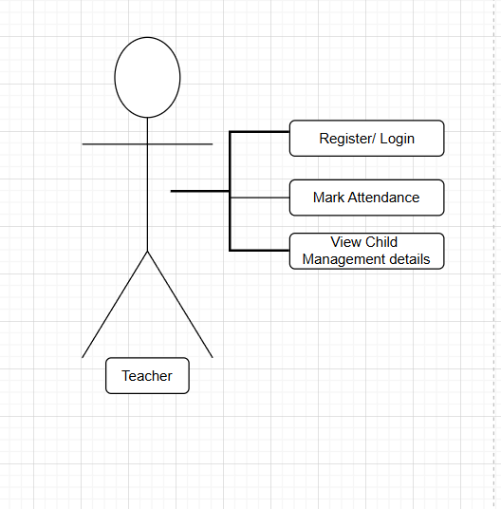
Figure 2: UML Diagram for the Teacher (Mthenjana, 2025).
Actor: Teacher
- The stick figure labeled Teacher represents the user role — a teacher who interacts with the system.
- The teacher is an external actor, meaning they use the system but are not part of its internal operations.
Use Cases
Each rounded rectangle shows a function that the Teacher can perform in the system. These are connected to the teacher actor, showing their interactions.
- Register/Login
  - Teachers can create an account or sign in to access their dashboard and class-related information.
  - Authentication ensures that only authorized teachers can access child and attendance data.
- Mark Attendance
  - Teachers can record daily attendance for the children in their class.
  - This information is then stored in the system and can be viewed by parents or administrators.
  - It helps track attendance trends and monitor absences.
- View Child Management Details
  - Teachers can view profiles of children, including personal details, allergies, parent contact info, and progress reports.
  - This feature helps teachers manage each child’s needs efficiently and ensure safety and well-being.
Purpose of the Diagram
- This diagram visually defines the teacher’s interactions with the app.
- It clarifies what functions the teacher can perform and helps in designing system permissions and interface layout.
- It also complements other use case diagrams (like the Parent and Admin diagrams) to give a full view of the system’s functionality.
- (OpenAI, 2025)

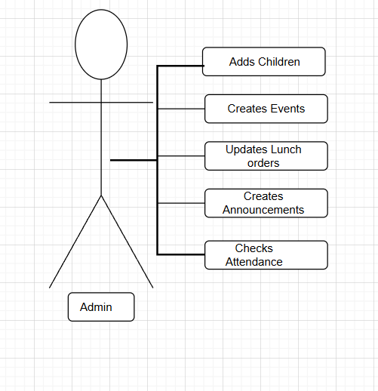
Figure 3: UML Diagram for the Admin (Mthenjana, 2025).

Actor: Admin
- The stick figure represents an actor, which is a user or role that interacts with the system.
- In this case, the actor is “Admin.”
- The admin is the person who performs or manages several operations within the system.
Use Cases (System Functions)
Each rectangle (rounded box) represents a use case, which is a specific functionality or action that the Admin can perform in the system.
The lines connecting the Admin to the boxes show the interactions or permissions the Admin has.
The use cases are:
- Adds Children
The Admin can register or add new children (users, students, or participants) to the system.
- Creates Events
The Admin can create and manage events (e.g., school functions, activities, or meetings).
- Updates Lunch Orders
The Admin can update or manage the lunch orders for children, possibly tracking what each child orders.
- Creates Announcements
The Admin can make announcements that are visible to other users (e.g., parents, teachers, or children).
- Checks Attendance
The Admin can view or update attendance records to monitor who is present or absent.
Summary of Meaning:
This use case diagram shows that:
The Admin is the main user role interacting with the system.
The Admin can perform five major actions (use cases).
The lines indicate direct relationships between the Admin and the system functions.
- (OpenAI, 2025)

Referencing
Mthenjana, M., 2025. UML diagram of a parent diagram. [Personal drawing]. Durban North: Unpublished.
Mthenjana, M., 2025. UML diagram of a admin diagram. [Personal drawing]. Durban North: Unpublished.
Mthenjana, M., 2025. UML diagram of a parent diagram. [Personal drawing]. Durban North: Unpublished.
Mthenjana, M., 2025. UML diagram of a teacher diagram. [Personal drawing]. Durban North: Unpublished.

